CSIS 5300 Final Project (100 points)

I have choose E-commerce business model

1. **Requirements**

List out the business requirements that a database designer would need to design the database by answering the following questions:

* 1. What operations will be captured by the database?

The suggested e-commerce platform database efficiently manages transactions (purchases and sales), product inventory control, customer interactions, and supplier relations. To ensure customer pleasure and operational efficiency, the platform will allow real-time transaction processing and order placement. The inventory management system will monitor and update stock levels, preventing stock-outs and overstocks. A database will store and retrieve client interaction histories to provide broad customer relationship management and personalised marketing and service. Supplier relationship management is connected to streamline communication and transactions with different suppliers, maintaining a stable supply chain and inventory diversification.

* 1. What information needs to be tracked?

Customers, products, orders, and suppliers will be fully tracked in the database. Customers' names, addresses, and contact information are critical for order fulfilment and customer care. Products are recorded by SKU, description, price, supplier, and stock level for proper inventory management and pricing. Financial reporting and customer relationship management require order tracking, which includes order dates, product quantities, total payments, and client IDs. Supplier names, contact information, and product lists aid purchasing and supply chain management.

* 1. What are the relationships and constraints?

Multiple linkages and restrictions assure data integrity and represent real-world business operations in the database design. Customers can place repeated orders, demonstrating customer-business involvement. Every order can have several products, therefore a junction table manages the many-to-many link. Another many-to-many relationship is needed to represent product providers. The requirement that every order contain a product prevents empty orders from being processed. Referential integrity rules that prevent orphan records in relational tables will also be enforced to guarantee database consistency.

1. **ER Diagram**

Use [ERDPlus](https://erdplus.com/) to model the requirements. Your model should contain the following:

* 1. Minimum 4 entities with attributes

Customer (Customer_ID, Name, Address, Email)

Product (Product_ID, Name, Description, Price, Stock)

Order (Order_ID, Customer_ID, Order_Date, Total)

Supplier (Supplier_ID, Name, Contact_Info)

* 1. Relationships, cardinalities, and constraints

A customer can place multiple orders (1 to many).

An order can contain multiple products (many to many).

Suppliers provide multiple products (1 to many).

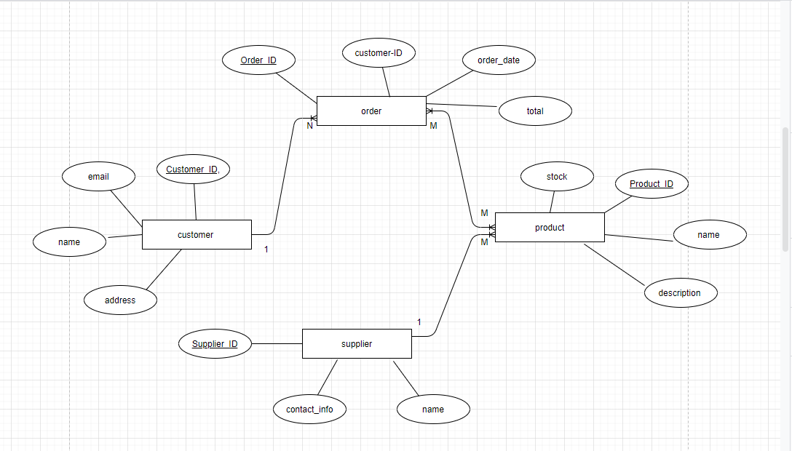

1. **Relational Schema**

Map the ER Diagram into a relational schema. Your schema should contain the following:

* 1. Minimum 4 relations (tables) with attributes (columns)
     1. Be sure to use correct labeling/notation of primary keys, foreign keys, optional attributes, etc.
  2. Relationships

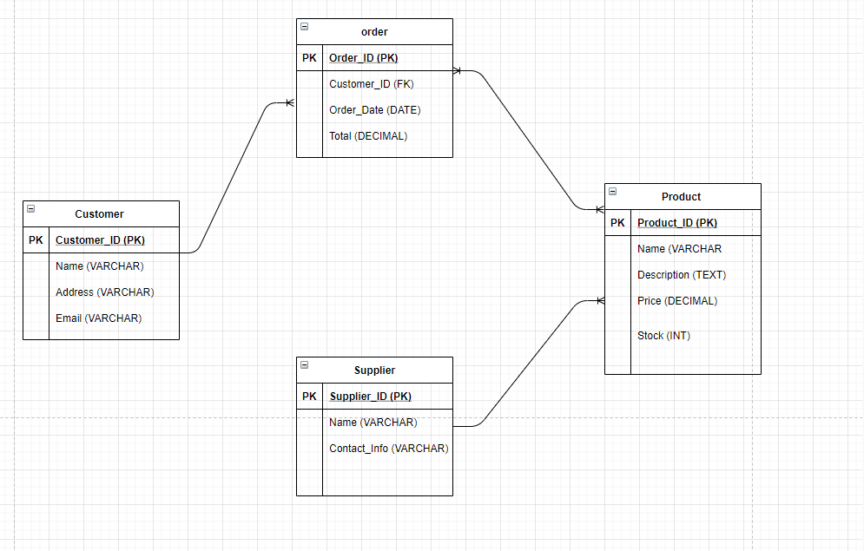

1. **Referential Integrity Constraints**

List any Update/Delete or user defined constraints.

Update/Delete Rules:

Customer Table

Delete: CASCADE So, if there is a customer to be deleted, his/ her orders should also be deleted; otherwise orphaned orders would not point to any customer.

On Update: On the update of Customer_ID, update this in the Order table to maintain integrity of links.

Product Table

On Delete: Either SET NULL or NO ACTION on Order_Product table. This depends on the business logic; if you want to save order history, SET NULL can remove a product reference but retain the order; NO ACTION does not allow deletion while the product is part of any orders.

On Update: Updates the Product_ID in the Order_Product table so that any references remain valid.

Table Order

On Delete: This should be set to CASCADE on the Order_Product table. With every order delete, the product linkages related to it would be deleted from the Order_Product table to avoid any orphan entries.

On Update: This means changing the Order_ID in the Order_Product table of its entries upon update, in order to maintain data integrity.

Table of Suppliers

On Delete: Usually either SET NULL or NO ACTION on the Product table depending on whether you want to keep or discard products which were supplied by a now deleted supplier. On SET NULL, the supplier reference in products will be cleared.

ON UPDATE: If there is an update in the Supplier_ID, it will be reflected in the Product table in case the supplier details get updated.

User Defined Constraints:

Stock Levels: Ensure that Stock in the Product table cannot go below zero.

SQL Example: CHECK (Stock >= 0)

Order Total: Ensure that the Total value in the Order table cannot be negative.

SQL Example: CHECK (Total >= 0)

Order Quantity: In the Order_Product table, ensure that the quantity of products ordered is greater than zero.

SQL Example: CHECK (Quantity > 0)

Valid Email: In the Customer table, ensure that the email address adheres to a valid format.

SQL Example: CHECK (Email LIKE '%_@__%.__%')

1. **Implementation SQL**

Provide the DDL (CREATE) and DML (INSERT INTO) SQL statements needed to implement your database design. Your SQL statements should include the following:

* 1. Minimum 10 records in at least 1 relation
  2. Minimum 1 record in all other relations
  3. Each relation/entity represented in relational/ER model should be implemented
  4. Data types should reasonably match each attribute
  5. Primary/Foreign keys, indexes and any non-implicit referential integrity constraints

SQL DDL Statements

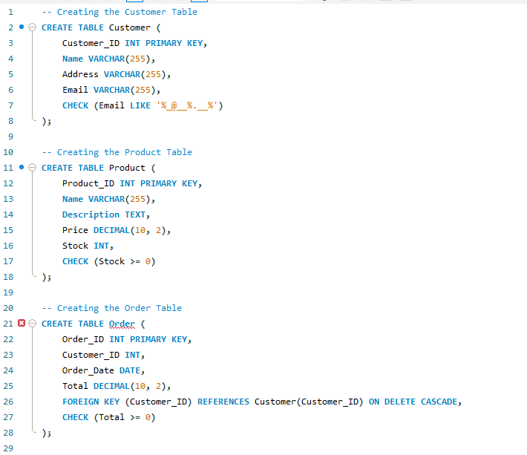

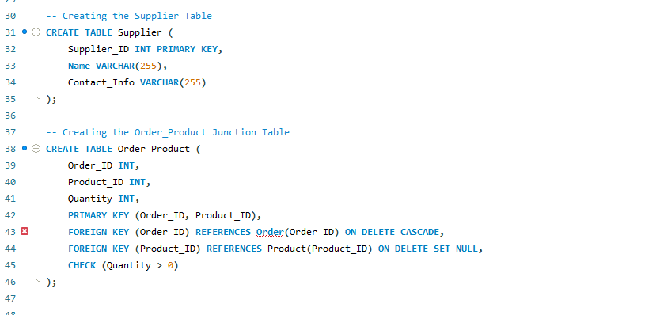

SQL DML Statements

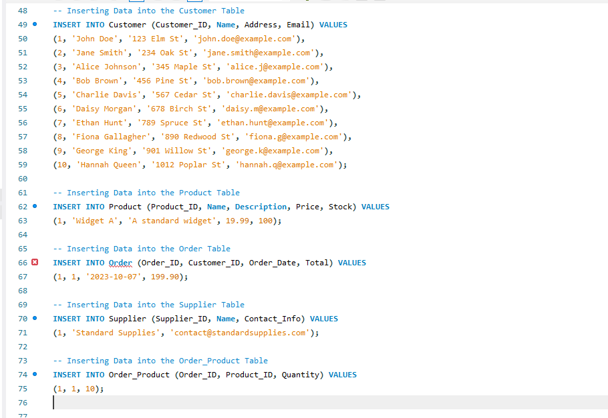

1. **Data Warehouse Requirements**

List out the requirements for a subject of analysis that uses your database as a source by answering the following questions:

* 1. What is the subject of analysis?

The subject of analysis is Sales Performance. This includes assessing sales performance, identifying customer buying habits, and enhancing product offerings and marketing methods using sales data. The goal is to increase income, discover successful items, and better match consumer expectations with inventories and marketing.

* 1. What fields or attributes will be useful in the analysis?

Several operational database fields are needed to analyze sales performance:  
  
Product Names: Product names help identify successful products.  
Product Categories: Aggregates and analyzes sales by category to determine popular and profitable categories.  
Sales Quantities: Essential for inventory management and planning; measures product volume.  
Sales Amounts: Revenue is essential for financial analysis and product or category performance.  
Customer Locations: Helps with sales analysis, market penetration, and regional marketing.

* 1. What is the granularity of the facts/measures?

The facts/measures are per-sale transaction. The data warehouse's fact table will contain one sales transaction per record, including product, quantity, total sale amount, and customer. This granularity permits extensive research and digging into single transactions to find trends, patterns, and anomalies.

These requirements will help build a data warehouse that can handle sophisticated sales performance queries and provide actionable insights to support decision-making. This configuration is essential for changing business strategy to consumer behavior and market changes.

1. **Star Schema of Data Warehouse**

Use [ERDPlus](https://erdplus.com/) to model the requirements. Your model should contain the following:

* 1. Minimum 3 dimensions
  2. Minimum 1 fact/measure

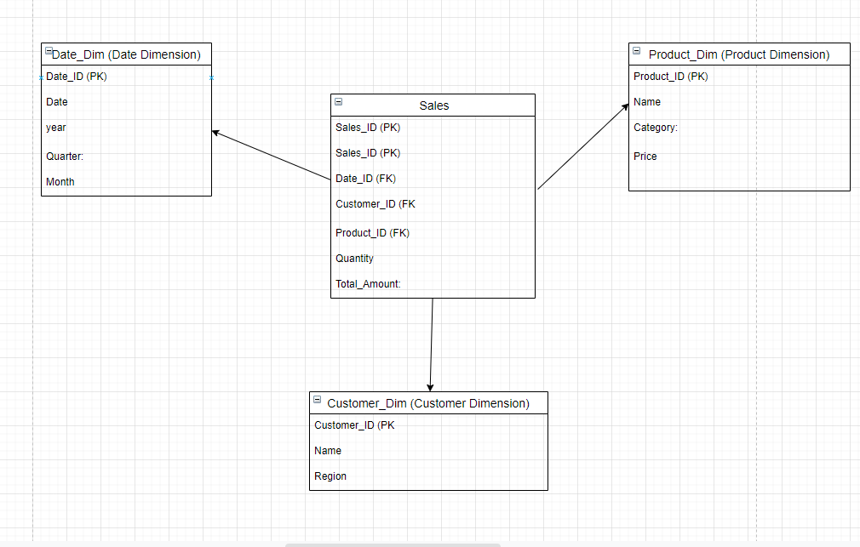

**References**

Data, B. M. C. M. D., Kumar, A., Mishra, A., & Kumar, S. Architecting a Modern Data Warehouse for Large Enterprises.

Kraiem, M. B., & Feki, J. (2024). Building a Data Warehouse for Social Media: Review and Comparison. *Computación y Sistemas*, *28*(1), 19-39.

Turken, G., Temirbekova, Z., Naizabayeva, L., & Barata, M. M. (2023). Study on a Data Warehousing for E-commerce Logistics. In *DTESI (workshops, short papers)*.